COVID-19 TESTING OPTIONS AT PERKINELMER GENOMICS
In order to support public health efforts, PerkinElmer Genomics has launched both a molecular SARS-CoV-2 RT-PCR assay for the rapid detection of current COVID-19 infection as well as serology assays that can detect IgA and/or IgG antibodies associated with a COVID-19 infection.

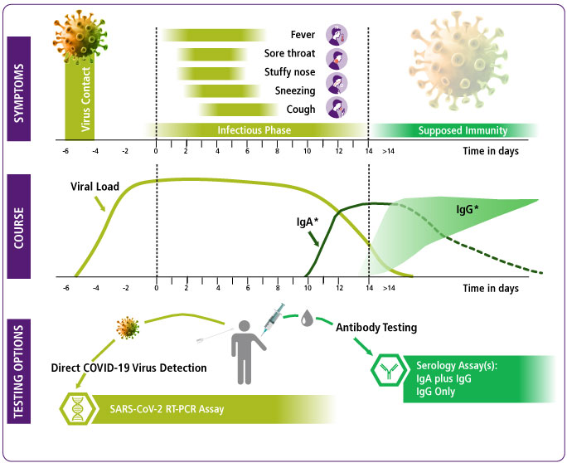
SARS-CoV-2 RT-PCR ASSAY
PerkinElmer Genomics has launched two laboratory developed tests (LDT) that can be used for the rapid detection of an active COVID-19 detection. Both of our SARS-CoV-2 RT-PCR assays (PerkinElmer assay and EURORealTime assay) include internal control (IC) that serve as both the extraction and amplification controls.

SEROLOGY ASSAY
PerkinElmer Genomics serology assay utilizes the Enzyme Linked ImmunoSorbent Assay (ELISA) test that provides in vitro determination of human antibodies against the SARS-CoV-2. This test can independently detect immunoglobulin classes IgA and IgG against the SARS-CoV-2.
- The EUROIMMUN Anti-SARS-CoV-2 ELISA (IgG) assay is intended for use as an aid in identifying individuals with an adaptive immune response to SARS-CoV-2, indicating recent or prior infection. The positive percent agreement to PCR was 100% at and after 21 days following the onset of symptoms while the overall negative percent agreement to presumed negatives was 99%.

PerkinElmer Genomics is concentrating on providing testing for large medical institutions, local governments, and employers in an effort maximize our reach and testing capabilities. If you would like to learn more about our testing options, please contact: Glenn Beers at glenn.beers@outlook.com

